Send Squash – a 2-player micro dexterity game

Components
5 discs – 1 orange (pumpkin), 2 green and 2 yellow (squash)
1 pole (stem)
1 ramp

Goal
The first player to break the stem off the pumpkin by using the ramp to send their squash wins the game

Setup
- Select play surface; ideally a smooth table or play mat 2-3’ per side
- Set the ramp aside within reach of both players
- Place the pumpkin disc in the center of the game with its stem on top
- Players choose squash colors and collect their 2 matching discs; randomly determine player to go first

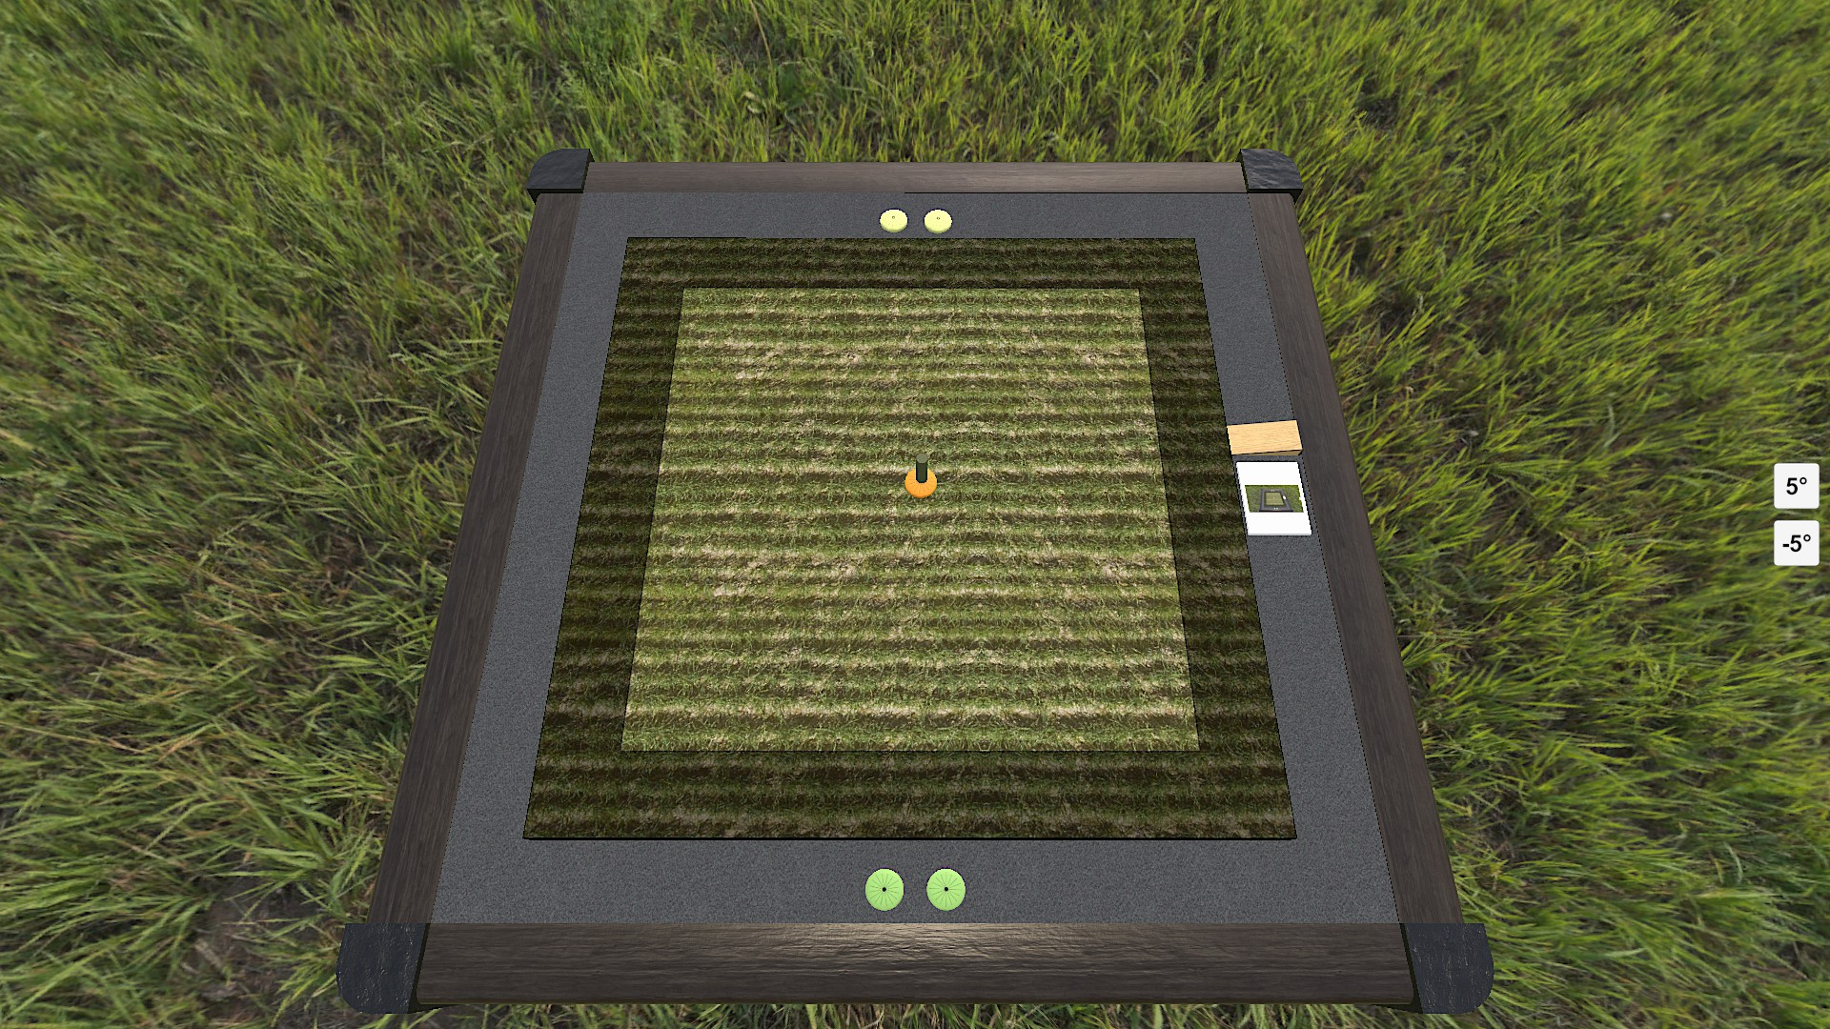

Infield vs Outfield
The play area is divided into 2 area: the infield and the outfield. Place either end of the ramp on the edge of the play area – the space along the ramp around the perimeter of the play area is the outfield; see shaded area in setup image above. The rest of the play area is the infield.

Game Play
Players take turns flicking 1 of their squash with following results:
- If the pumpkin is knocked into the outfield (or out of play) the other player places the it along the edge of the play area, flicks it back into the infield and places its stem on top
- Otherwise, if the pumpkin’s stem is knocked over then put it back and the player flicks again (once per turn)
- Otherwise the player’s turn ends

Note: If either of the player’s squash are currently out of play, such as on their first turns or if knocked out of play, then the player must place 1 on the edge of the play area and flick it into play.

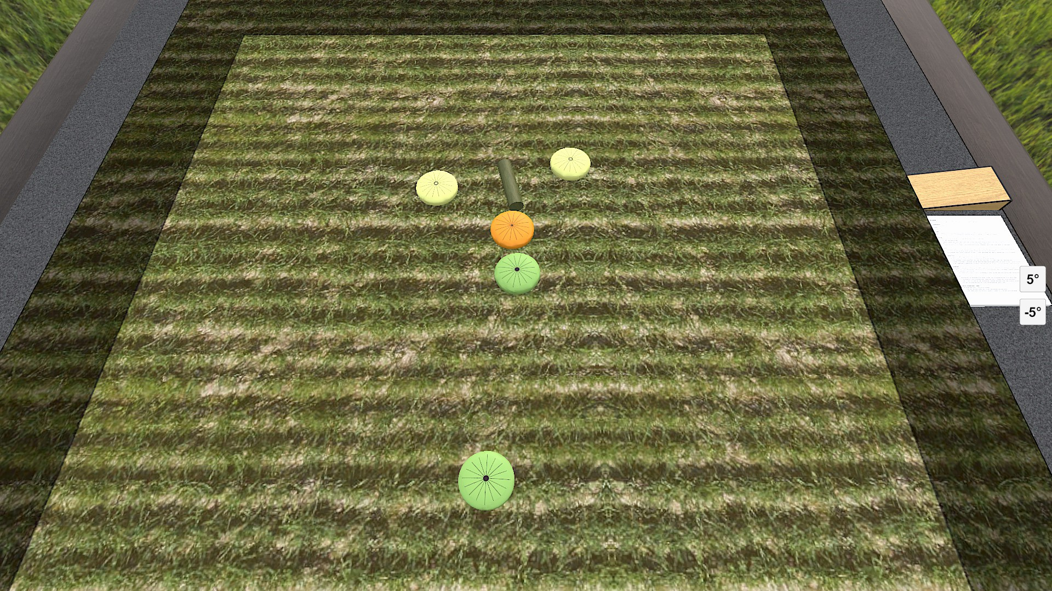

Send It!
If both of the player’s squash are in the infield they may use their flick to attempt to break the pumpkin’s stem:
- Place the ramp between their 2 squash so that the taller side of the ramp is against the squash closest to the pumpkin
- The further squash is then flicked in an attempt to travel up the ramp and knock down the stem while airborne

Notes:
- The ramp must be able to fit between the 2 squash
- If the flicked squash touches the table before striking the stem or the stem remains upright then both the flicked squash and the ramp are removed from play and the player’s turn ends

Example of successful Send It!

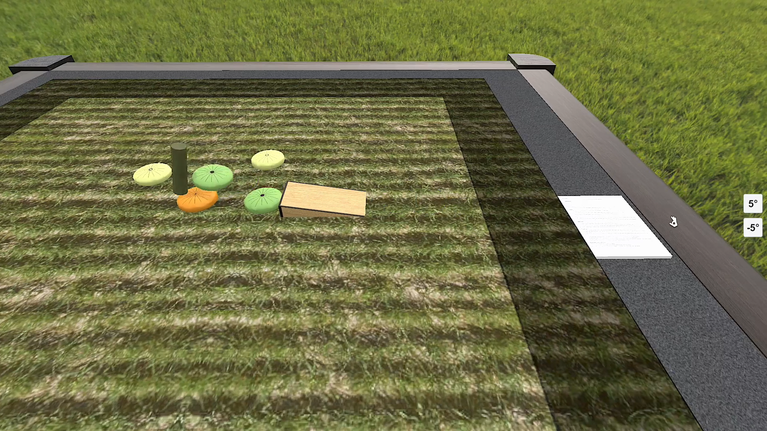

End of the Game
The first player to successfully Send It! wins the game!

Note: for a longer game players can play 3 or 5 rounds alternating taking the first turn with the player winning the most rounds being declared the winner of the game.

Links
Discuss on Board Game Geek: https://boardgamegeek.com/thread/2492441
Play on Tabletop Simulator: https://steamcommunity.com/sharedfiles/filedetails/?id=2630958675
Follow along on Discord: https://discord.gg/yZKgfuHEr7

